|  |  |
| --- | --- |
| Project name | Real time river water quality monitoring using IOT |
| Team id | PNT2022TMID47948 |
| Team Members | 1.David Samuvel.P  2.Jagadeeswaran.N  3.Karthikeyan K.K  4.Karthick Raja.V  5.Jashrelal Maya.P |
| Branch | Computer Science and Engineering |

Introduction:

Water is the primary need of all living beings and living without water is impossible. With the advancement of technology and industrialization, environmental pollutions have become a major concern. Water pollution is one of the most serious types of this environmental pollution. Our lives depend on the quality of water that we consume in different ways, from juices which are produced by the industries. Any imbalance in the quality of water would severely affect the humans health and at the same time it would affect the ecological balance among all species. Water quality refers to the chemical, biological, radiological, and biological parameters of the water.

The essential parameters of the water quality vary based on the application of water. For example, for aquariums, it is necessary to maintain the temperature, pH level, dissolved oxygen level, turbidity, and the level of the water in a certain normal range in order to ensure the safety of the fish inside the aquarium. For the industrial and household applications, however, some parameters of the water are more essential tobe monitored frequently than the others, depending on the usage of the water.

* 1. Project overview:

Real-time water quality monitoring uses**technologically advanced monitoring sensors** to collect in-stream water quality measurements and make data available for analysis and action in real time. Field teams deploy sensors strategically at designated points in a given surface water area to monitor waters within defined measurement parameters.

* 1. Purpose:

Monitoring water quality is clearly important because in our seas, our rivers, on the surface and in our ports, for both companies and the public. It enables us to assess how they are changing, analyze trends and to inform plans and strategies that improve water quality and ensures that water meets its designated use.

2.Literature Survey:

Water is one of the major compounds that profoundly influence ecosystem. But, nowadays it is been exploited heavily due to rapid industrialization, human waste and random use of pesticides and chemical fertilizers in agriculture, which leads to water contamination. Thus, a water monitoring system is necessary to observe the water quality in a large area such as lake, river, and aquaculture. As per the current world situation, Internet of Things (IoT) and remote sensing techniques are used in heterogeneous areas of research for supervising, congregate and analyzing data from the remote locations. In this paper, the suggested system is a minimal price real time water quality monitoring system in IoT environment. This system comprise of numerous sensors for assessing the physical and chemical parameter. The factors of water that can be assessed using these sensors are pH, turbidity, conductivity, dissolved oxygen. Using this system the real time quality of water bodies can be determined and the data uploaded over the Internet are analyzed.

* Jayti Bhatt,Jignesh Patoliya entitled “Real Time Water Quality Monitoring System”.This paper describes to ensure the safe supply of drinking water the quality should be monitored in real time for that purpose new approach IOT (Internet of Things) based water quality monitoring has been proposed. In this paper, we present the design of IOT based water quality monitoring system that monitor the quality of water in real time. This system consists some sensors which measure the water quality parameter such as pH, turbidity, conductivity, dissolved oxygen, temperature. The measured values from the sensors are processed by microcontroller and this processed values are transmitted remotely to the core controller that is raspberry pi using Zigbee protocol. Finally, sensors data can view on internet browser application using cloud computing.
* Aswinkumar et al.[4]: This research paper focuses on Detection on water pollution and water management using smart sensors iotTo ensure the safe supply of drinking water the quality should be monitored in real time for that purpose new approach IOT (Internet of Things) based water quality monitoring has been proposed.This system consists some sensors. Which measure the water quality parameter such as pH, turbidity, conductivity, dissolved oxygen, temperature. The measured values from the sensors are processed by microcontroller and these processed values are transmitted remotely to the core controller that is raspberry pi using Zigbee protocol. Based on a study of existing water quality monitoring system and scenario of water we can say that proposed system is more suitable to monitor water quality parameters in real time. Based on a study of existing water quality monitoring system and scenario of water we can say that proposed system is more suitable to monitor water quality parameters in real time.

2.1 Existing Problem:

The already existed product have to analyse the data of the turbidity level and give data flow according to its value.

It doesn’t values the level of the turbidity that present in the water bodies.It only recognize the data of the moisture level in the water.

2.2 New Feature:

In our project the LED display is used to analyze the data level of moisturation that present in the water.

At the same time the Ph level of the water present in the water resources are also been identified in the same product.

The product is been controlled by the mobile app with the use of Wi-Fi in their own places that the customer stayed.

2.3 Problem Statement:

Due to the fast growing urbanization supply of safe drinking water is achallenge for the every city authority. Water can be polluted at any time. Sothe water we reserve in the water tank at our roof top or basement in our society or apartment may not be safe. Still in India most of the people usesimple water purifier that is not enough to get surety of pure water. Sometimesthe water has dangerous particles or chemical mixed and general purposewater purifier cannot purify that. And it’s impossible to check the quality of water manually in every time. So an automatic real-time monitoring system isrequired to monitor the health of the water reserved in our water tank of thesociety or apartment. So it can warn us automatically if there is any problemwith the reserved water. And we can check the quality of the water anytimeand from anywhere.

What are the objectives?

● To measure various chemical and physical properties of water likepH, temperature and particle density of water using sensors.

● Send the data collected to  Raspberry Pi, show the display and send data to cloud display.

● Trigger alarm when any discrepancies are found in the water quality.

● Data visualization and analysis using cloud based visualizationtools.

3.Ideation:

The monitoring involves conducting field measurements and collecting water samples for laboratory analyses of over 50 physico-chemical and biological parameters, including organics, nutrients, metals and E. coli bacteria, serving the following purposes:**evaluate the pollution status of rivers;** monitor long-term changes in river water quality monitoring by the IOT.

3.1 Empathy map

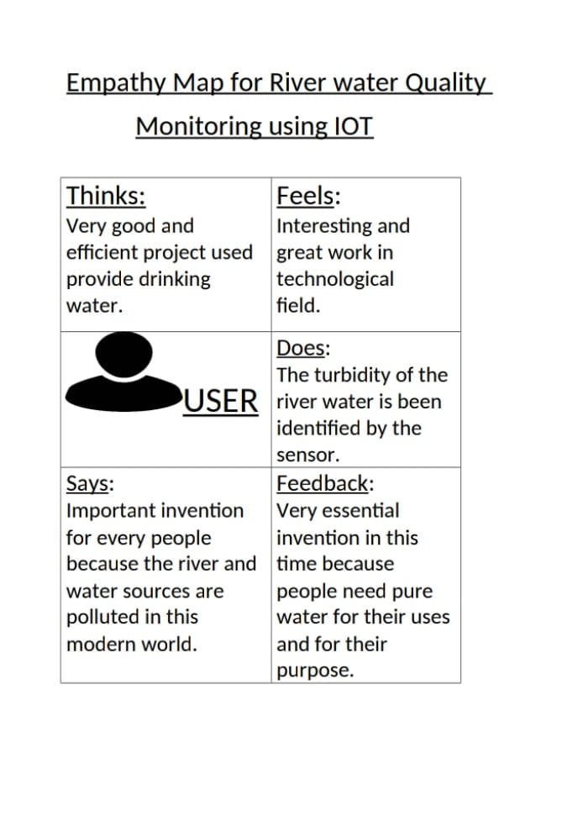

3.2 Brainstroming:

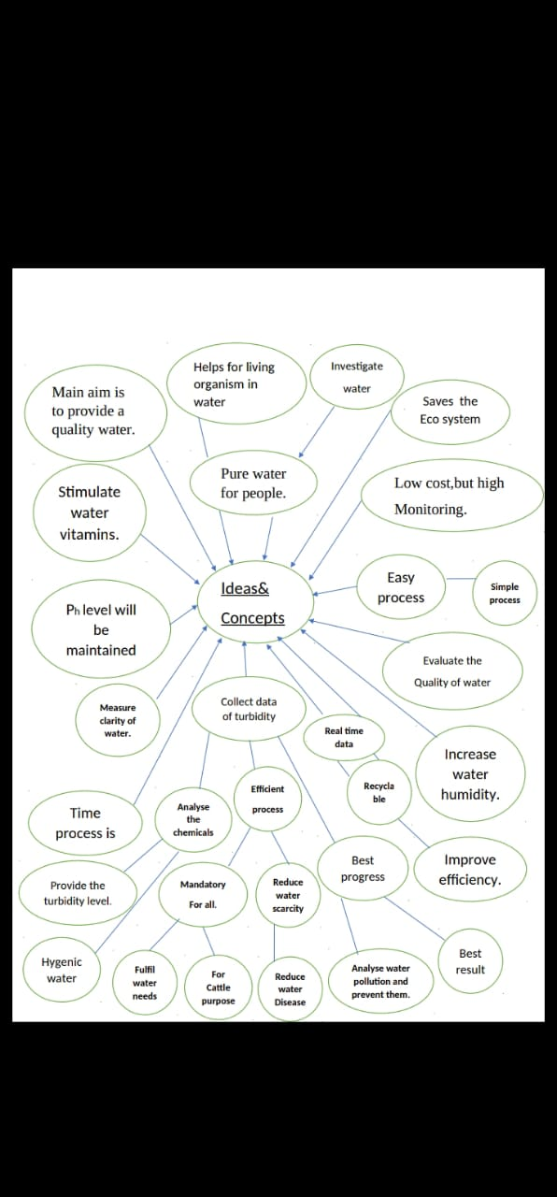

3.3 Propsed Solution:

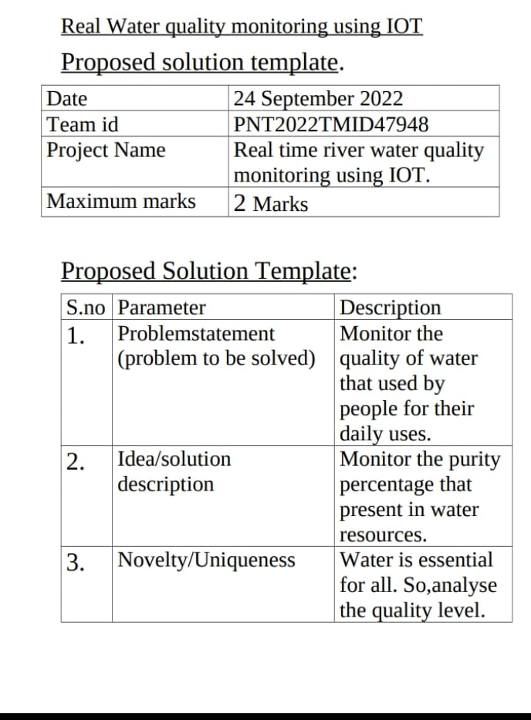

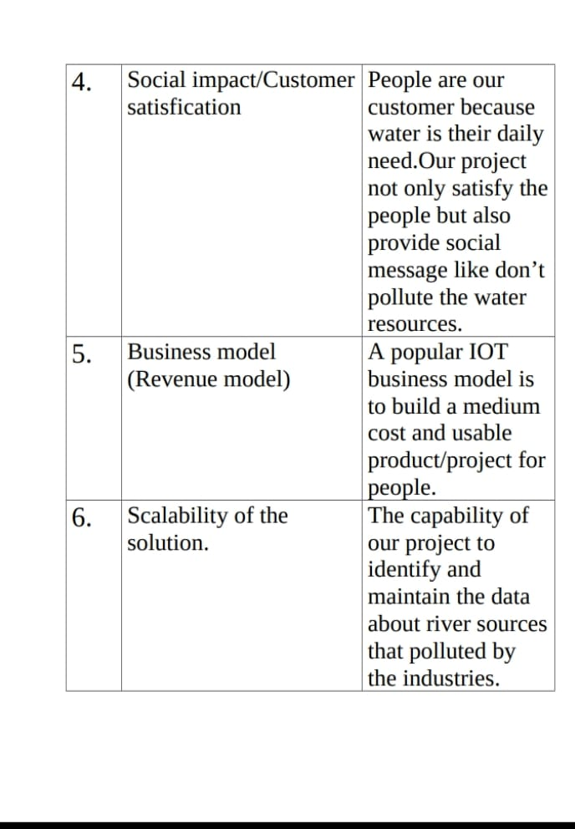

3.4 Problem solution fit:

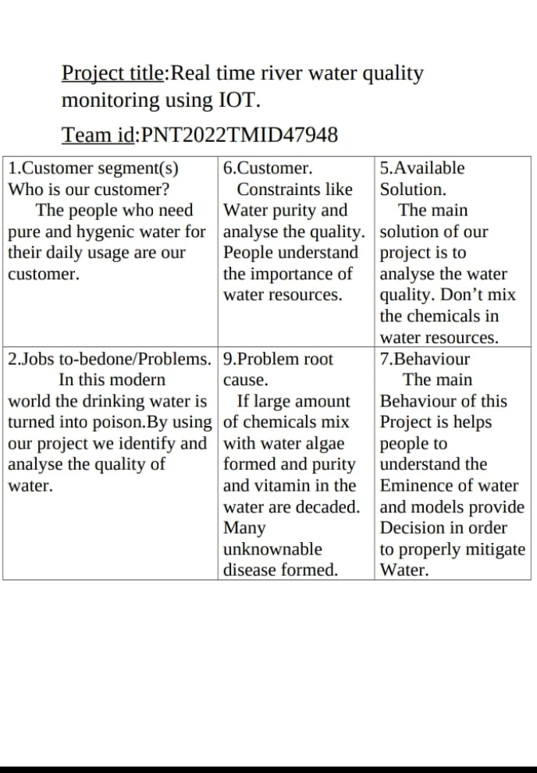

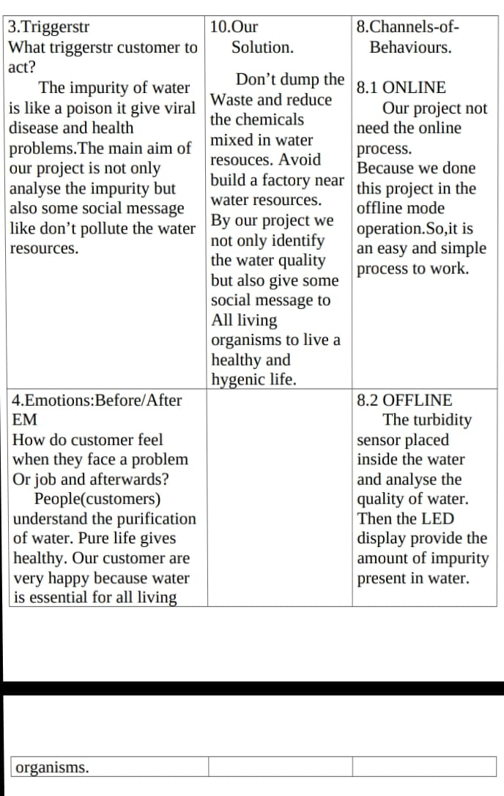

4.Requirement Analysis:

The river water quality monitoring is done in the basis of the following requirements.

The system uses the advanced technologies like turbidity sensors,Ph meter etc to detect the values of the turbidity in the water resources.

4.1 Functional Requirements:

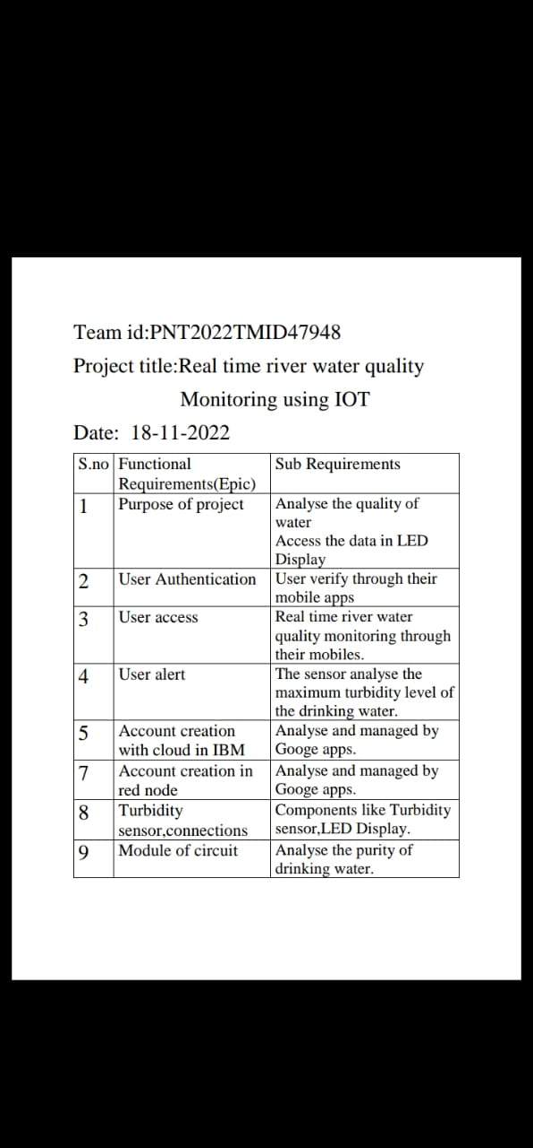

5.Project design:

Water quality monitoring (WQM) is crucial for managing and protecting riverine ecosystems. Current WQM network design practices often rely on unsubstantiated criteria rather than accountable algorithms. Water managers face difficulties to relate the impact of local boundary conditions on the choice of appropriate WQM network design methods. After reviewing the commonly used design methods and their resulting monitoring setups, it was evident that multivariate statistical analysis is the most frequently used method for designing WQM networks in rivers.

Turbidity sensor:

The turbidity sensor**detects water quality** by measuring level of turbidity. It is able to detect suspended particles in water by measuring the light transmittance and scattering rate which changes with the amount of total suspended solids (TSS) in water. As the TTS increases, the liquid turbidity level increases.

LED Display:

LED Display (light-emitting diode display) is a screen display technology that uses a panel of LEDs as the light source. Currently, a large number of electronic devices, both small and large, use LED display as a screen and as an interaction medium between the user and the system. Modern electronic devices such as mobile phones, TVs, tablets, computer monitors, laptops screens, etc., use a LED display to display their output.

Ph level sensor:

A pH sensor is a**scientific device used to accurately measure acidity and alkalinity in water and other liquid substances**. It is an important device used in most industries, including power plants, pharmaceuticals, food & beverage, primaries, chemicals, oil gas, and wastewaters.

IBM Watson cloud:

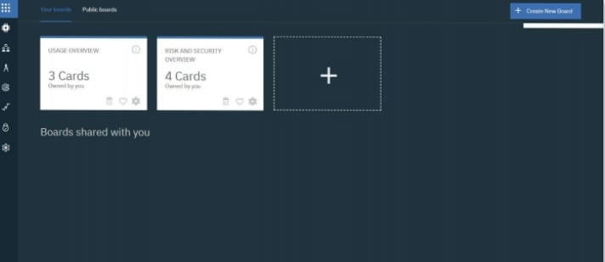

Watson is an AI from IBM. Created to form your business more intelligent and every worker your best worker. Watson features a range of advanced APIs, specialized tooling, and Software as a Service application. This implies that Watson is made for complex use cases and designed to integrate with platforms that experts utilize in their daily work. Ensuring seamless access to the knowledge you would like to form the right decisions.

Uses of IBM Watson:

* Watson gives you complete control of what is important to you and therefore the foundation of your competitive advantage, your data, models, learning, and API.
* Watson learns more from less because of its high learning power.
* Watson was initially available only on IBM Cloud but is now portable across any cloud-powered business. This prevents customers from being locked into one vendor and enables them to start out deploying AI wherever their data resides.

Aurdino-UNO:

The Arduino UNO is a standard board of Arduino. Here UNO means 'one' in Italian. It was named as UNO to label the first release of Arduino Software. It was also the first USB board released by Arduino. It is considered as the powerful board used in various projects. Arduino.cc developed the Arduino UNO board.

Arduino UNO is based on an ATmega328P [microcontroller](https://www.javatpoint.com/microcontroller). It is easy to use compared to other boards, such as the Arduino Mega board, etc.

Node-Red process:

Node-RED is a**flow-based development tool for visual programming** developed originally by IBM for wiring together hardware devices, APIs and online services as part of the Internet of Things. Node-RED provides a web browser -based flow editor, which can be used to create JavaScript functions.

**License:**[Apache License 2.0](https://www.bing.com/ck/a?!&&p=788a338a0f7fa4c5JmltdHM9MTY2ODcyOTYwMCZpZ3VpZD0wYjgzZWNkYi1jMzg0LTYxM2ItMjQyOC1mZDJiYzIyOTYwZjkmaW5zaWQ9NTQ4Nw&ptn=3&hsh=3&fclid=0b83ecdb-c384-613b-2428-fd2bc22960f9&u=a1L3NlYXJjaD9xPUFwYWNoZStMaWNlbnNlKzIuMCt3aWtpcGVkaWE&ntb=1)

**Operating system:**[Cross-platform](https://www.bing.com/ck/a?!&&p=755fae7f1fb90d11JmltdHM9MTY2ODcyOTYwMCZpZ3VpZD0wYjgzZWNkYi1jMzg0LTYxM2ItMjQyOC1mZDJiYzIyOTYwZjkmaW5zaWQ9NTQ4OA&ptn=3&hsh=3&fclid=0b83ecdb-c384-613b-2428-fd2bc22960f9&u=a1L3NlYXJjaD9xPUNyb3NzLXBsYXRmb3JtK3dpa2lwZWRpYQ&ntb=1)

**Stable release:**3.0, / July 14, 2022; 3 months ago

**Written in:**[JavaScript](https://www.bing.com/ck/a?!&&p=caf2490dae500d86JmltdHM9MTY2ODcyOTYwMCZpZ3VpZD0wYjgzZWNkYi1jMzg0LTYxM2ItMjQyOC1mZDJiYzIyOTYwZjkmaW5zaWQ9NTQ5MA&ptn=3&hsh=3&fclid=0b83ecdb-c384-613b-2428-fd2bc22960f9&u=a1L3NlYXJjaD9xPUphdmFTY3JpcHQrd2lraXBlZGlh&ntb=1)

Working Principle:

Monitoring consists of a systematic and planned series of measurements or observations that are appropriately analysed and reported, to generate information and knowledge about a water body.

Water quality monitoring provides us with information on the health of waterways and for the management of catchments, water resources and the environment. Monitoring may be required for single studies and to focus on particular issues or knowledge gaps, or it may be part of a more regular ongoing operation.

Monitoring data are essential for people involved in planning, licensing and approval processes and natural resource management, as well as agencies, consultants, researchers and community groups interested in monitoring, assessment and reporting.

* + Define the information requirements and [monitoring program objectives](https://www.waterquality.gov.au/anz-guidelines/monitoring/program-objectives).
  + [Design a monitoring study](https://www.waterquality.gov.au/anz-guidelines/monitoring/study-design), including its type, scale, measurement parameters and sampling programs, including preferred methods for sampling.
  + Determine the preferred approach for field sampling ([field sampling design](https://www.waterquality.gov.au/anz-guidelines/monitoring/field-sampling-program)), including how to prepare, collect and preserve samples of waters, sediments and biota efficiently and safely.
  + Design a program for[laboratory processing and analyses](https://www.waterquality.gov.au/anz-guidelines/monitoring/laboratory-analysis) of water, sediment and biota samples that provides accurate results in an efficient and safe manner.
  + [Analyse and interpret the data collected](https://www.waterquality.gov.au/anz-guidelines/monitoring/data-analysis) with respect to the monitoring program objectives and the underpinning conceptual models of the study area.
  + [Report and disseminate information and results](https://www.waterquality.gov.au/anz-guidelines/monitoring/reporting) from the monitoring program in ways that address different stakeholder needs and backgrounds.

5.1 Data Flow Diagram:

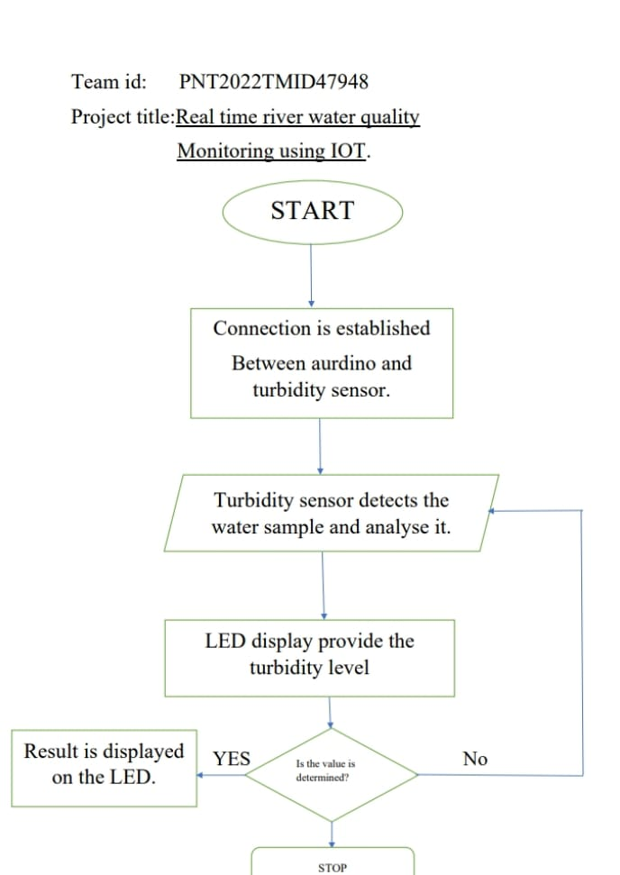

5.2 Technical Architecture:

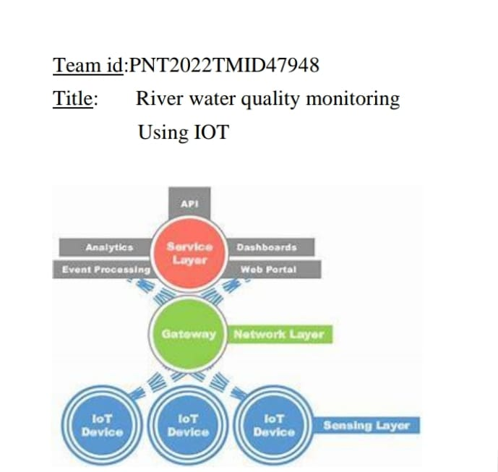

5.3 Mobile app recogniztion:

The mobile app is used to control and monitor the turbidity and Ph level of the water resources.

The Wi-fi source is connected to the mobile app and the data are recorded by mobile as shown below.

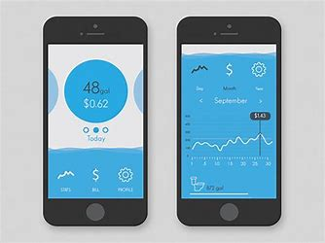

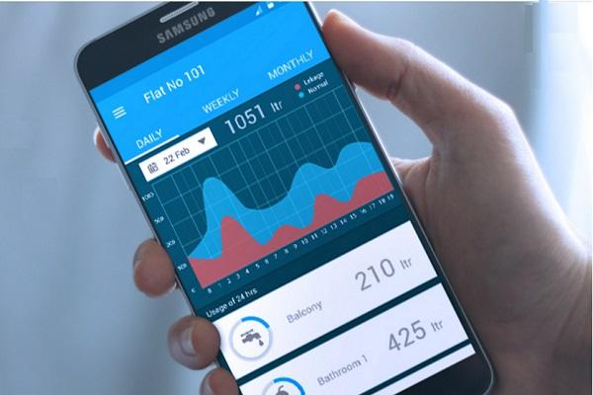

6.Project Planning and Scheduling:

Taking the proper steps to set up a sound water quality monitoring plan is an excellent way for students to learn about their watershed, how their home or school fits into it, and how scientists approach their work. As we work toward our capstone site study, the steps we take in investigating our water quality are very important. The data we obtain for our suite of parameters (pH, DO, turbidity and temperature) are only as good as the method or plan we use to collect it. Recognizing the limitations of field methods and additional factors that may affect our data will be key steps in arriving at an accurate conclusion to our testable question and developing any plans for further action and reporting.

When using the World Water Monitoring Day test kits, there are some strengths and weaknesses in the quality of the data collected. On the positive side, the kits are easy to use, provide quick results and are comparable to the thousands of other study sites using them.

6.2 Sprint delivery plan:

The project must be planned to do in 2-3 months.

According to our scheduling process of the working,the project is done in these following weeks and completed by our team-mates successfully.

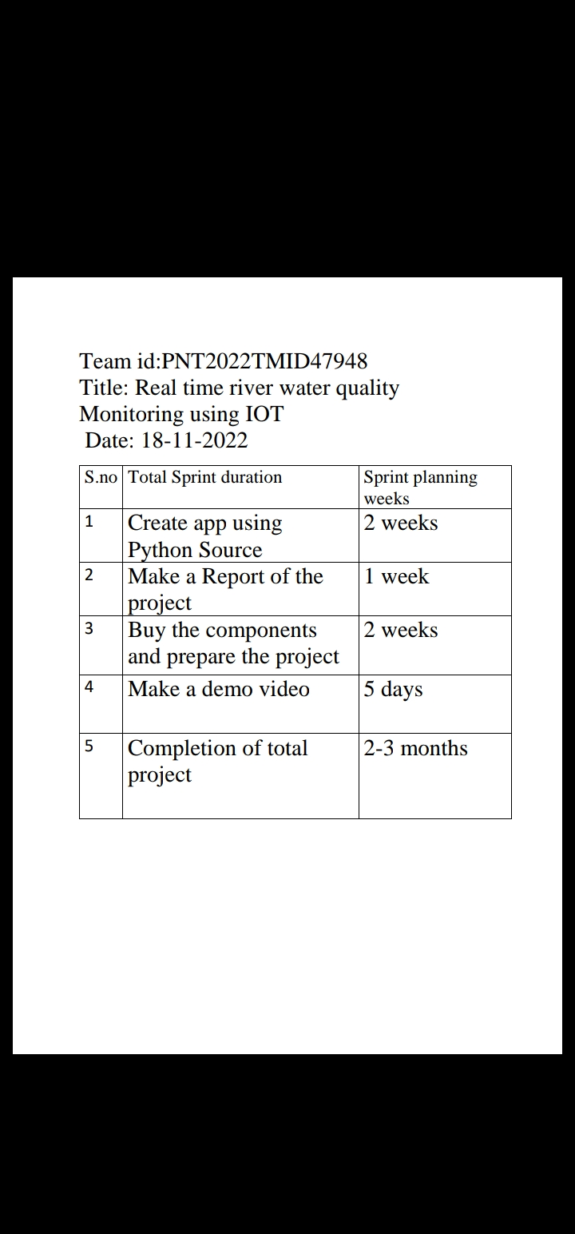

These are the following schedule that proceed by our team to complete the project successfully.

Budget:

The process in done by the following permitted budget

* Turbidity sensor
* LED display
* Aurdino UNO
* Connecting wires

Total budget of the project is Rs.6,000-10,00(approx).

7.Testing:

Water quality assessment provides the base line information on water safety. Since water quality in any source of water and at the point of use, can change with time and other factors, continuous monitoring of water is essential. WHO guidelines provide values for 96 substances (out of 128 chemicals initially reviewed). It is very expensive, time consuming, difficult and largely unnecessary to test for all these parameters. The list of parameters to be selected from the guidelines and included in any water assessment and monitoring program will vary according to the local conditions. This Technical Bulletin aims at providing parameters that are basic and generally considered priorities in any water quality assessment programme. It also presents the testing kits that have been identified so far by UNICEF for assessment and monitoring programmes.

The following basic parameters should be included:

1. Microbiological parameters: basic microbiological tests should cover thermo- tolerant coliforms (a group of bacteria that grow at 44°C) and faecal streptococci. In addition, physical and chemical parameters, such as disinfectant residuals, pH and turbidity, affect the microbiological quality of water.

2. Physical parameters: in addition to turbidity, mentioned above, conductivity, colour, taste and odour might cause rejection of water.

3. Harmful chemicals: nitrate, iron, arsenic, fluoride, lead, cyanide, metals (aluminium, cadmium, chromium, copper, manganese, mercury), selenium, organics (including pesticides and disinfectant by-products), alkalinity and corrosivity.

7.2 Testing methods:

There are some testing methods like

1.Physical parameters

* 1. Colour:

This is usually monitored through visual observation only. It is simple and cost free. However, for quantitative assessments, a light box or a spectrophotometer should be used.

1.2Odour:

Assessment of odour is usually not included in the water quality assessment. If a change in odour is detected, it might indicate a water quality problem that requires further investigation.

2. Chemical parameters

The basic chemical parameters that are generally included in water assessment and monitoring programmes are shown in the table below. They were determined at the Rapid Water Quality Assessment Meeting held by WHO, UNICEF and the Water, Engineering and Development Centre (Loughborough University) in Bangkok on 5-7 May 2002. Local conditions could lead to some variations in the parameters selected.

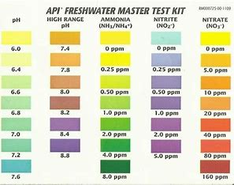

8.Results:

The result of our work can be shown in a curve that is generated in the ThingSpeak, that is calculated and monitored from a different sensor like pH, turbidity, and temperature sensor and uploaded in it. Different curves and widgets are used to show the results of different sensors respectively. The curve is made as the sensors calculate the input data for different dates and times. Also used ThingSpeak mobile app, fig 13. for getting the results of the sensor in mobile phones, fig 14. Then IFTTT applets within the webhook services and the services provided by ThingSpeak like ThingHTTP and ThingSpeak React by using the URL of IFTTT applets to send the notification or push message to the owner’s registered number.Results in ThingSpeak Asian Journal of Convergence in Technology ISSN NO: 2350-1146 I.F-5.11 Volume VII and Issue II 4.

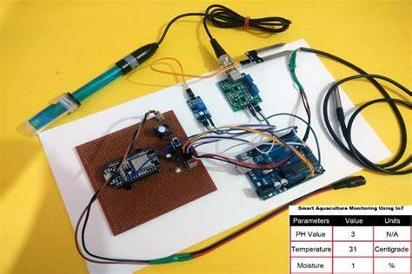

9.Future work planning:

In future the process will get a progress and used to analyse the chemical properties also,

The future plan is been reviewed as the following diagram.

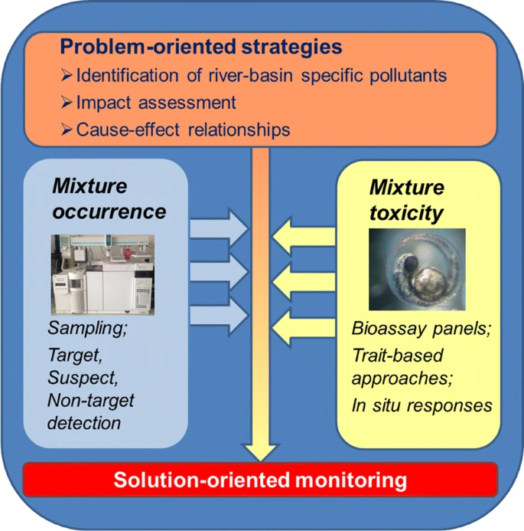

10.Used program:

import time.sleep

while True

totalVoltageReading = 0

for count in range(800):

currentVoltageReading = float(anlogRead(rpiGpioSensorPinNum / 1023) * 5) totalVoltageReading = totalVoltageReading + currentVoltageReading averageVolteageReading = totalVoltageReading / 800

roundedUpAverageVoltageReading = round(averageVoltageReading)

if roundedUpAverageVoltageReading < 2.5:

nephelometricTurbidityUnit = 3000

elif nephelometricTurbidityUnit = -(1120.4 * square(roundUpAverageVoltageReading) + (5742.3 * roundUpAverageVoltageReading - 4353.8) lcd.clear() lcd.setCursor(0, 0) lcd.print(roundedUpAverageVoltageReadin g, "V") lcd.setCursor(0, 1) lcd.print(nephelometricTurbidityUnit, "NTU")

sleep(10)

11. Advantages and Disadvantages:

Advantages:

* **Leads to Better Health:** Water quality monitoring system will help us to know the most healthy water in the plant, and it can lead to better health too. Quality water helps prevent waterborne illness.
* **Leads to Better Water Treatment:** In general, water treatment is one of the most important and sometimes the only thing that needs be done in a business because if there is any problem with water, it will affect the productivity of a company.
* **Cost Effective:**Quality water monitoring system can save a lot of money for you. This is because if you have a big company and it takes more than 5,000 liters of water in your plant per day, then your monthly bill will be more than 1 crore if you are using untreated water.
* **Performance:**Quality water monitoring system can help you to check your performance with water quality testing methods. This is because you can use those testing results and compare them with the performance of your plant and adjust that points where you are lacking.

Disadvantages:

* **Labor Intensive For Installation And Operation:** Quality water monitoring system requires a lot of man hours for its installation and operation. This is because water quality monitoring system consists of multiple instruments and they all are very time consuming.
* **Maintenance Costs:**Because of high labor intensive and high initial costs, quality water monitoring system has a high maintenance cost which is why after some time you will have to replace your entire system.
* **Time Consuming:**Quality water monitoring system is very time consuming and the whole procedure is not reliable. This is because with water quality monitoring system you will have to change your test report every month, but some companies will ask for test reports every week or even daily.

12.Conclusion:

Water level and quality is an important aspect in many applications such as chemical industries, household, pharmaceutical industries, nuclear power generation plants etc. This paper concludes literature review of the level and quality of the water using different international conference and journal papers. The proposed methodology can be used for the objective of this paper. If it is achieved helps in saving man power and electricity.

13.Reference:

T.Deepiga, A.Sivasankari-Smart water monitoring system using wireless sensor network, Journal in Engineering & Technology Science (IRJET), Volume: 02 Issue: 04 , pp 1305-1314, July-2015.

Praseed Kumar, Shamim S Pathan, Bipin Mashilkar, Liquid Level Control using PID Controller Based on Labview & Matlab Software , International Journal of Engineering Research & Technology (IJERT).

Muthamil Selvan.S , Aratrika Roy, Kurnal Pratap Singh, Ashutosh Kumar, AUTOMATIC WATER LEVEL INDICATOR USING ULTRASONIC SENSOR AND GSM MODULE, IJARIIE, Vol-4 , Issue-5, pp 261-269, 2018.

S.Jatmiko, A B.Mutiara, Indriati Prototype of water level detection system with wireless Journal in Theoretical and Applied Information Technology Vol. 37 pp 52-59, 2012.

Charles A, Ayylusamy C, Deepak Raj J, Keerthi Kumar, Thiruvarasan KE, IOT BASED WATER LEVEL MONITORING SYSTEM USING LABVIEW, International Journal of Pure and Applied Mathematics,

Volume 118, No. 20, 2018, pp 9-14

Lukman Adewale Ajao, Blessing Olatunde Abisoye, James Agajo,Abdulzeez Olorundare Ajao, Muhammed Bashir Muazu, Abdulazeez Femi Salami, Automated Multiple Water Tanks Control System Using ATMEGA and FPGA Technology, IEEE MAC 2019, pp 347-353.

S. M. Khaled Reza, Shah Ahsanuzzaman Md. Tariq, S.M. Mohsin Reza, Microcontroller Based Automated Water Level Sensing and Controlling: Design and Implementation Issue, Proceedings of the World Congress on Engineering and Computer Science 2010, Vol I October 20-22, 2010.

Laith Abed Sabri, Hussein Ahmed AL-Msha, Implementation of Fuzzy and PID Controller to Water Level System using LabView, International Journal of Computer Applications, Volume 116 No. 11, April 2015.

R. M. Shrenika, S. S. Chikmath, A. V. R. Kumar, Y. V. Divyashree and

R. K. Swamy, "Non-contact Water Level Monitoring System Implemented Using LabVIEW and Arduino," 2017 International Conference on Recent Advances in Electronics and Communication Technology (ICRAECT), Bangalore, 2017, pp. 306-309.

Vardaan Mittal, Automatic Water Level Controller, International Journal of Science and Research (IJSR), Volume: 6, Issue: 5, pp 136-138, May 2017.

Management (IWRM) is a strategic concept including

the coordinated development and management of

surface water and groundwater, river basins and its

adjacent coastal and marine environment, land use,

upstream and downstream interests, but also aspects

related to the human capacity to use and benefit of

this important natural resource (Teodosiu et al.,

2009).